Public Record
Lower Brule Sioux Tribe Brownfields/Tribal Response Program
(Updated 12/8/20)

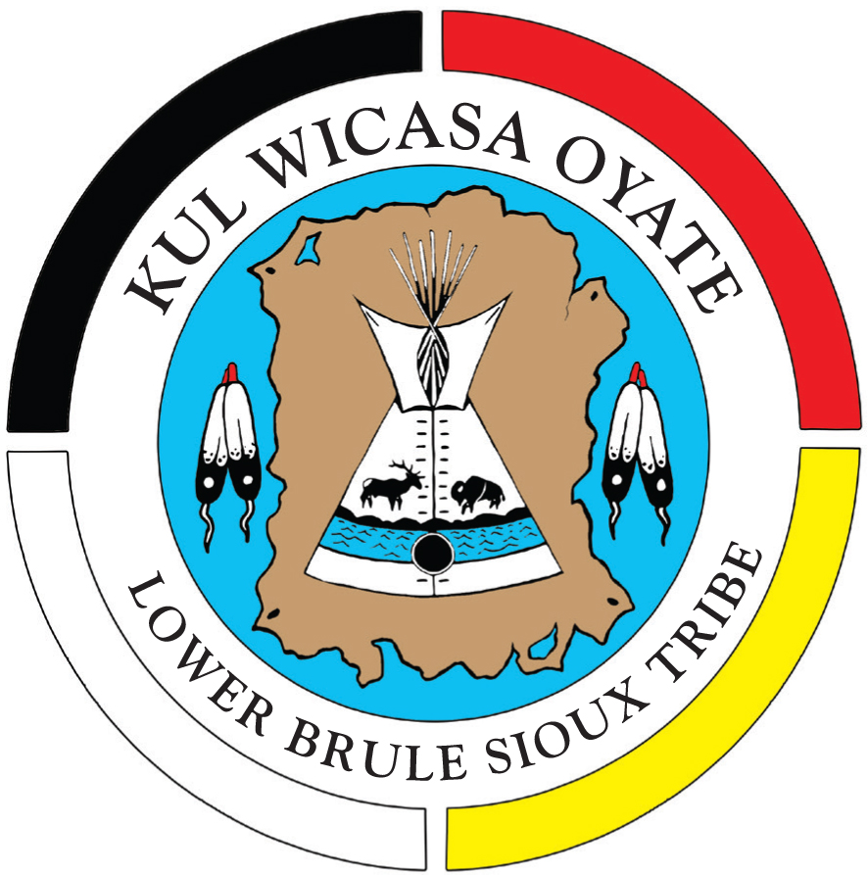

#511 Spotted Tail
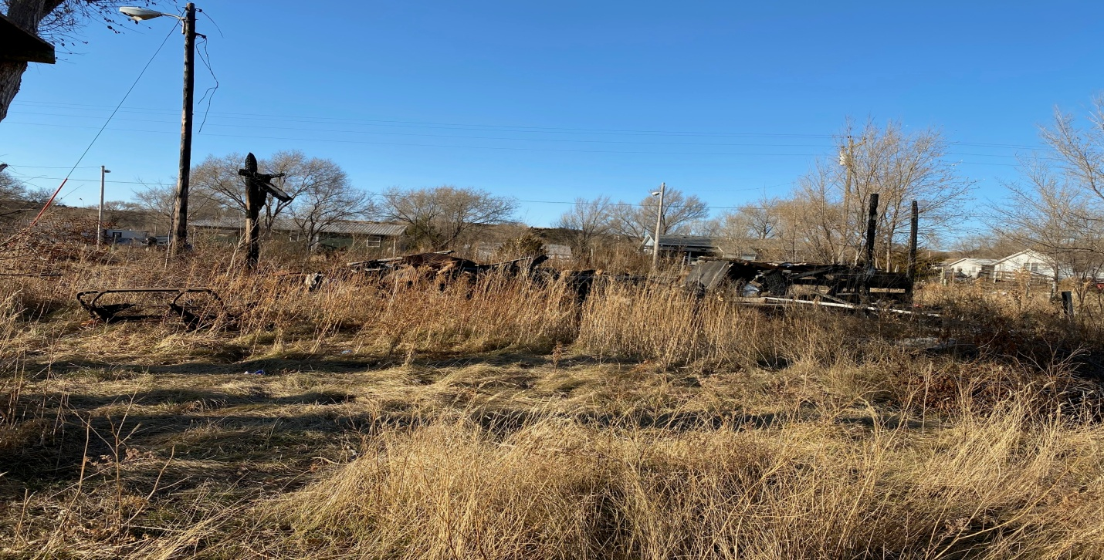
Site Name #511 Spotted Tail
Current Owner Lower Brule Sioux Tribe
Address #511 Spotted Tail St. Lower Brule, SD 57548
Lat/Long 44. 4’23”N 99.34’54”W

Date of:
Suspected Contaminants Asbestos- Lead Based Paint

Institutional Controls none
Site 0.32
Type of Site Old House
Date Action is Planned Spring 2021

#511 Spotted Tail North
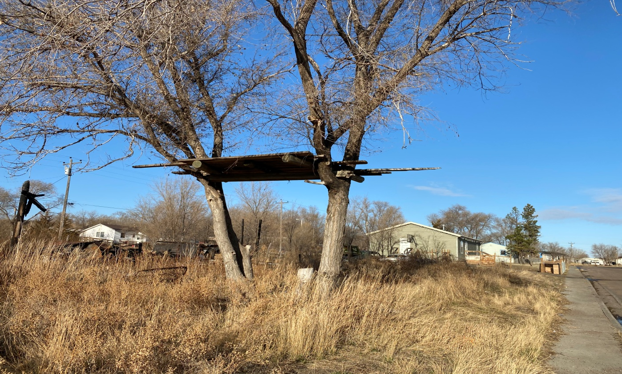
Site Name #511 Spotted Tail North
Current Owner Lower Brule Sioux Tribe
Address #511 Spotted Tail St. Lower Brule, SD 57548
Lat/Long 44. 4’23”N 99.34’53”W

Date of:
Suspected Contaminants Lead Based Paint

Institutional Controls none
Site 0.32
Type of Site old tree house
Date Action is Planned Spring 2021

#240 Spotted Tail
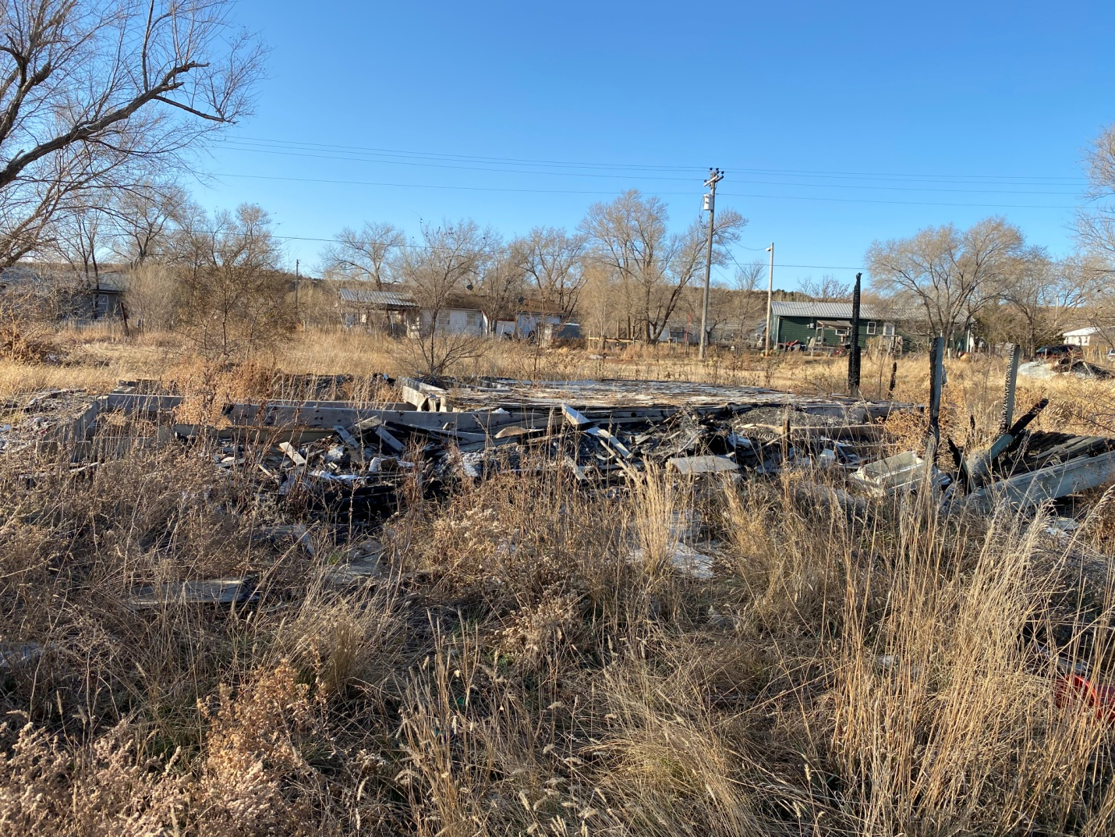
Site Name #240 Spotted Tail
Current Owner Lower Brule Sioux Tribe
Address #240 Spotted Tail St. Lower Brule, SD 57548
Lat/Long 44. 4’23”N 99.34’53”W

Date of:
Suspected Contaminants Asbestos- Lead Based Paint

Institutional Controls none
Site 0.32
Type of Site Old House
Date Action is Planned Spring 2021
#404 Spotted Hawk
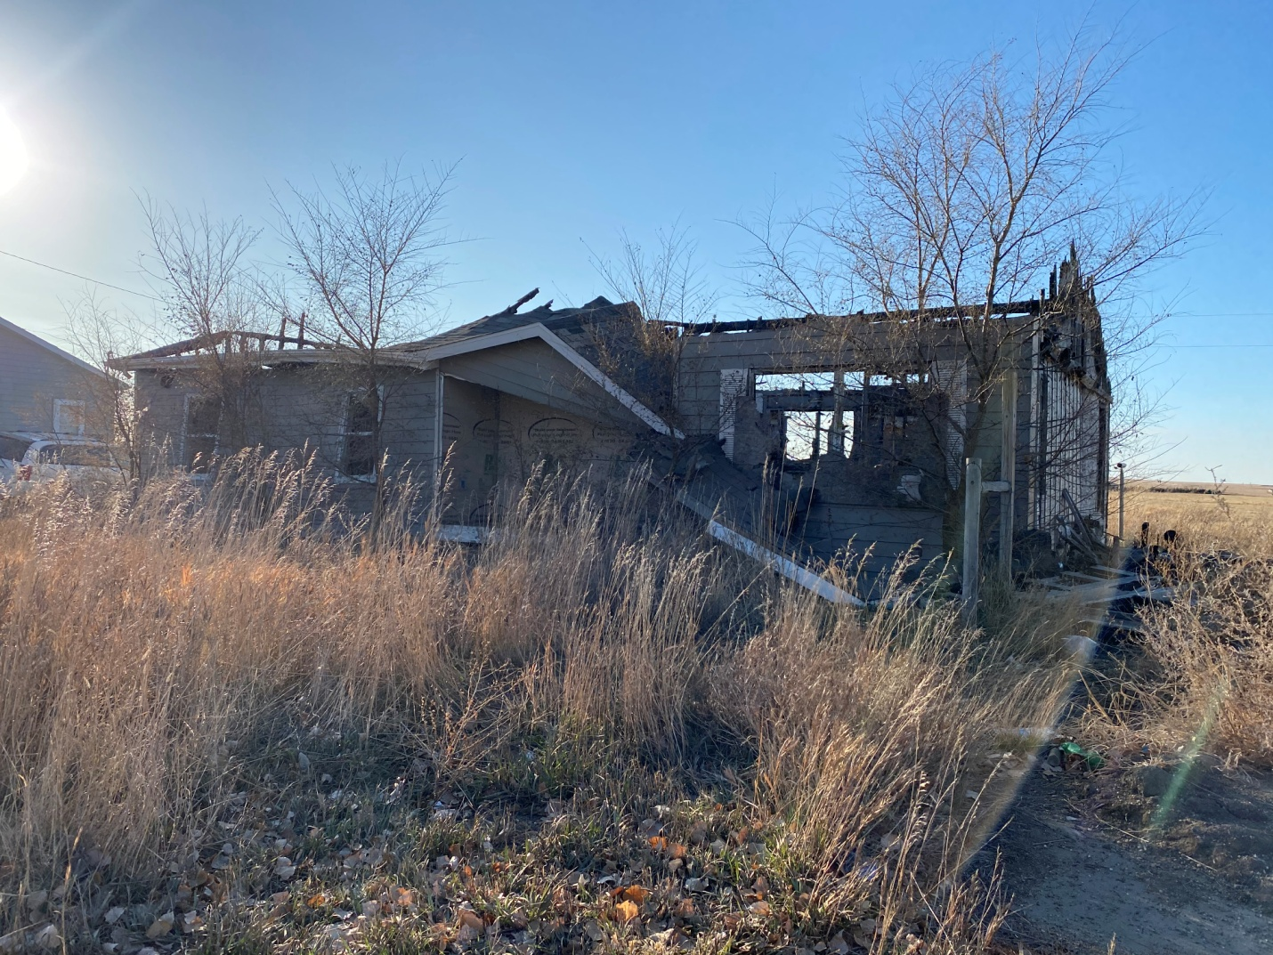
Site Name #404 Spotted Hawk
Current Owner Lower Brule Sioux Tribe
Address #404 Spotted Hawk St. Lower Brule, SD 57548
Lat/Long 44. 4’20”N 99.38’24”W

Date of:
Suspected Contaminants Asbestos- Lead Paint
Institutional Controls none
Site 0.35
Type of Site Old House
Date Action is Planned Spring 2021
#74 Sitting Bull
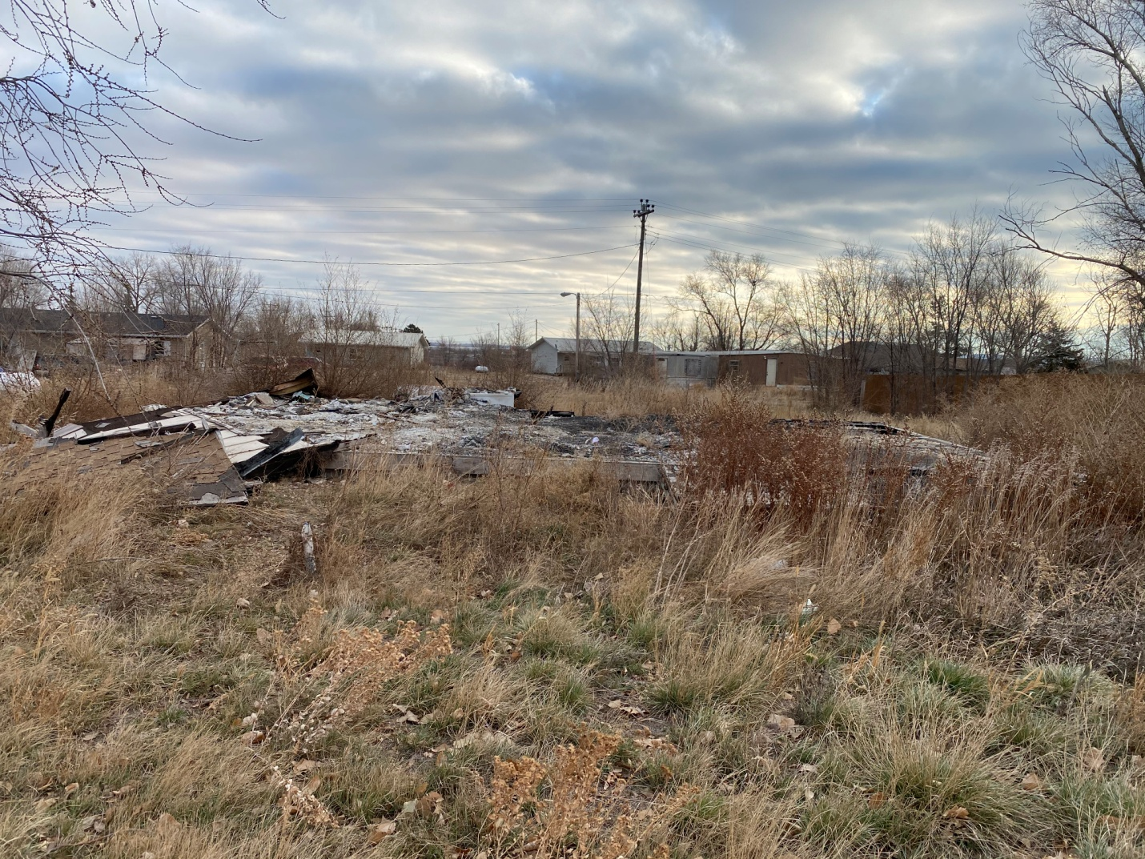
Site Name #74 Sitting Bull
Current Owner Lower Brule Sioux Tribe
Address #74 Sitting Bull St. Lower Brule, SD 57548
Lat/Long 44. 4’27”N 99.34’60”W

Date of:
Suspected Contaminants Asbestos- Lead Based Paint

Institutional Controls none
Site 0.32
Type of Site Old House
Date Action is Planned Spring 2021

